Republic of the Philippines

**CAVITE STATE UNIVERSITY**

**Don Severino delas Alas Campus**

Indang, Cavite

**COLLEGE OF ENGINEERING AND INFORMATION TECHNOLOGY**

**Department of Information Technology**

May 2021

**DR. DAVID L. CERO**

Dean, CEIT

This University

Sir,

We wish to apply for an oral review of our thesis outline entitled **“CodeNect: Visual Programming Software for Learning Fundamentals of Progamming”** on ________________________.

Thank you.

Respectfully yours,

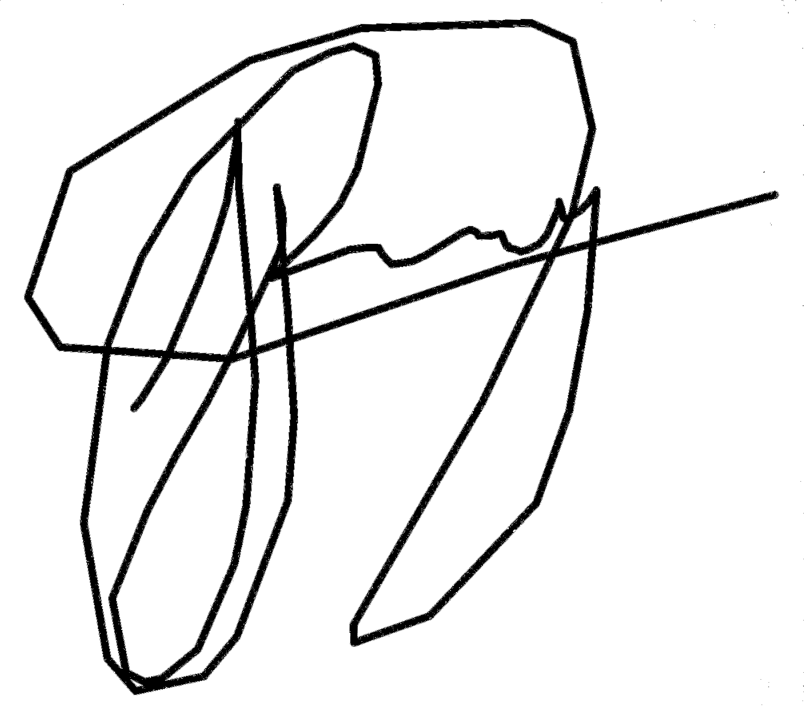

Brandon B. Lim-it

Jaykel O. Punay

RECOMMENDING APPROVAL:

**JAMES ANGELO V. AVES**

**ANABELLE J. ALMAREZ**

**________ ________**

Adviser Date Technical Critic Date

**GLADYS G. PEREY ________ MARLON R. PEREÑA ________**

Unit Research Coordinator Date Department Chairperson Date

**EDWIN R. ARBOLEDA ________**

College Research Coordinator Date

APPROVED:

**DAVID L. CERO ________**

Dean, CEIT Date